**OSH AUTHORITIES - PORTUGAL**

Source: <https://oshwiki.eu/wiki/OSH_system_at_national_level_-_Portugal>

* **OSH Infrastructure**

**Scheme**

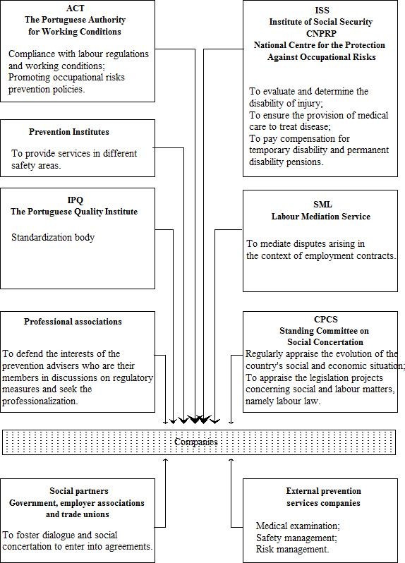

* **OSH auth****orities and inspection services**

|  |  |
| --- | --- |
| Name of the Authority | The Working Conditions Authority (ACT- Autoridade para as Condições de Trabalho) |
| Link | <http://www.act.gov.pt/(pt-PT)/Paginas/default.aspx> |
| Short abstract | The Working Conditions Authority (ACT- Autoridade para as Condições de Trabalho) is responsible for promoting improved working conditions by ensuring compliance with labour regulations and working conditions in the context of the private sector and compliance with working conditions in the public sector, and for promoting occupational risk prevention policies. The central services of ACT are located in Lisbon, and decentralized services, spread over all districts of Portugal.  The central services of ACT, are constituted by three service directorates and 10 divisions:   * Directorate of Support to the supervision (DSAAI); * Directorate for the Promotion of Safety and Health at Work (DSPSST); * Services Directorate for the Management Support (DSAG). |
| Link to OSH wiki | <https://oshwiki.eu/wiki/OSH_system_at_national_level_-_Portugal> |

|  |  |
| --- | --- |
| Name of the Authority | The Directorate-General for Employment and Labour Relations (DGERT- Direcção-Geral do Emprego e das Relações de Trabalho) |
| Link | <http://www.dgert.gov.pt/> |
| Short abstract | The Directorate-General for Employment and Labour Relations (DGERT- Direcção-Geral do Emprego e das Relações de Trabalho) is responsible for helping to develop policies on employment and vocational training and on labour relations, including working conditions and health, safety and welfare at work. It is also responsible for monitoring and encouraging collective bargaining and the prevention of trade disputes, and for promoting the accreditation of training bodies. |
| Link to OSH wiki | <https://oshwiki.eu/wiki/OSH_system_at_national_level_-_Portugal> |

|  |  |
| --- | --- |
| Name of the Authority | The Regional Inspectorate of Employment from the Regional Government of Açores (Inspecção Regional do Trabalho do Governo Regional dos Açores) |
| Link | <http://www.azores.gov.pt/Portal/pt/entidades/vp-irt/> |
| Short abstract | The Regional Inspectorate of Employment from the Regional Government of Açores (Inspecção Regional do Trabalho do Governo Regional dos Açores) has the mission to develop advisory methods and action and to perform inspections in companies and other organisations, with the fundamental aim of improving working conditions. |
| Link to OSH wiki | <https://oshwiki.eu/wiki/OSH_system_at_national_level_-_Portugal> |

|  |  |
| --- | --- |
| Name of the Authority | The Regional Directorate of Labour in the Autonomous Region of Madeira (Direção Regional do Trabalho da Região Autónoma da Madeira) |
| Link | <https://www.madeira.gov.pt/drtai/> |
| Short abstract | The Regional Directorate of Labour in the Autonomous Region of Madeira (Direção Regional do Trabalho da Região Autónoma da Madeira) has the mission to contribute to the improvement of working conditions and to the agreement on labour relations within Autonomous Region of Madeira. The Regional Directorate has expertise in the area of labor, specifically in the areas of labor legislation, collective bargaining, professional organizations, assessment of working conditions, safety and health at work, labor statistics, and more recently the voluntary resolution of work conflicts. |
| Link to OSH wiki | <https://oshwiki.eu/wiki/OSH_system_at_national_level_-_Portugal> |

|  |  |
| --- | --- |
| Name of the Authority | The Division of Environmental and Occupational Health (DSAO - Divisão de Saúde Ambiental e Ocupacional (DSAO) from Directorate General of Health (DGS – Direção Geral de Saúde) |
| Link | <https://www.dgs.pt/> |
| Short abstract | The Division of Environmental and Occupational Health (DSAO - Divisão de Saúde Ambiental e Ocupacional (DSAO) from Directorate General of Health (DGS – Direção Geral de Saúde) has responsibilities to propose strategies and specific programs for evaluation coordination and collaboration in the management of risk to human health in several areas, notably water, the built spaces, waste, chemical and biological substances, genetically modified organisms and ionizing and non ionizing radiation; for monitoring, technical advice and licensing facilities, equipment and chemical and biological substances in accordance with law; to propose strategies, coordinate activities and ensure programs within the occupational health; to propose strategies and coordinate programs and activities in ensuring the prevention of accidents. |
| Link to OSH wiki | <https://oshwiki.eu/wiki/OSH_system_at_national_level_-_Portugal> |

Internal link to enforcement indicator by MS

* **Compensation and Insurance bodies**

|  |  |
| --- | --- |
| Name of the Body | The Protection against Occupational Hazards Department (DPRP - Departamento de Protecção contra os Riscos Profissionais |
| Link | <http://www2.seg-social.pt/left.asp?05.17> |
| Short abstract | The Protection against Occupational Hazards Department (DPRP - Departamento de Protecção contra os Riscos Profissionais), is the service of the Institute of Social Security (Instituto de Segurança Social), nationwide responsible for managing the treatment and recovery from illness or disability arising from occupational hazards. According to Portaria) no. 135/2012 of 08 May the competences of DPRP at company level, are as follows:   * To evaluate and determine the disability of injury, functional disturbance or disease arising from occupational hazards; * To ensure the provision of medical care to treat disease or disability resulting from occupational hazards; * To pay compensation for temporary disability and permanent disability pensions; * To promote clinical recovery and professional reclassification of beneficiaries with an occupational disease; * To promote the placement of rehabilitated workers in occupations compatible with his physical condition and ability to work. |
| Link to OSH wiki | <https://oshwiki.eu/wiki/OSH_system_at_national_level_-_Portugal> |

* **Research institutes**

|  |  |
| --- | --- |
| Short abstract | Portugal does not run a national OSH research institute.  Research in the field of safety and health at work is mainly carried out by research groups at universities and also at technology centers, which often have projects in collaboration with universities. There is a national network that encompasses the eight existing technology centers, promoting the cooperation among them |
| Link to OSH wiki | <https://oshwiki.eu/wiki/OSH_system_at_national_level_-_Portugal> |

* **Other OSH Services**

|  |  |
| --- | --- |
| Name of the service | The Portuguese Association of Occupational Safety and Health Companies (APEMT – Associação Portuguesa de Empresas de Segurança e Saúde no Trabalho) |
| Link | <http://www.apemt.com/> |
| Short abstract | The Portuguese Association of Occupational Safety and Health Companies is a private nonprofit association whose object is to represent, defend and promote the common interests of the Occupational Health and Safety companies. |
| Link to OSH wiki | <https://oshwiki.eu/wiki/OSH_system_at_national_level_-_Portugal> |

* **Standardization Bodies**

|  |  |
| --- | --- |
| Name of the Body | The Portuguese Quality Institute (IPQ – Instituto Portugues da Qualidade) |
| Link | <http://www.ipq.pt/backhtmlfiles/ipq_mei.htm> |
| Short abstract | The Portuguese Quality Institute (IPQ – Instituto Portugues da Qualidade) is the national organization that manages and promotes the development of the Portuguese System for Quality (SQP - Sistema Português para a Qualidade), with its three sub-systems - Standardization, Metrology and Qualification. Therefore, IPQ is the Portuguese representative body in the quality field at international level, and keeps a close co-operation with its European counterparts. Within the SPQ framework, IPQ copes with the role of National Standardization Body (ONN), thus ensuring the co-ordination with European and International standardization bodies, and supervises the activity of the Central Laboratory of Metrology. |
| Link to OSH wiki | <https://oshwiki.eu/wiki/OSH_system_at_national_level_-_Portugal> |